EF has many ways to specify how classes are **mapped to tables**..

If DB tables we‘re working against don‘t match our entity classes.. we have to fix that..

Assume our Semester calss maps to a table called year_semesters, tnat thtat the PROPERTIES IN OUR CLASS DON‘T HAVE THE SAME NAMES AS THE COLUMNS IN THE TABLE..

Can create a special MAP CLASS.. which **MAPS OUR ENTITY CLASS TO THE TABLE..**

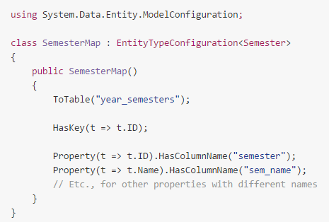

Thus in our DataContext class.. we must remember to add an instance of that class to the **OnModelCreating** method..

